
Assessment Cover Page
Student Full Name | Eusha Ibne Nur Sami
Student Number | 2024431
Module Title | Distributed Digital Transactions
Assessment Title | Ca-1(40%)
Lecturer/Supervisor | Dr. Muhammad Iqbal
Assessment Due Date | Friday, 13 November 2026, 11:59 PM
Date of Submission

Declaration of AI Use — AI Fluency Framework
This assessment applies to CCT College Dublin's AI Fluency Framework — four interconnected competencies that ensure your engagement with AI is effective, efficient, ethical and safe: Delegation, Description, Discernment and Diligence. Full detail on what AI use is permitted for this assessment, and the evidence you must provide, is set out in your Assessment Brief.
Delegation  Setting goals and deciding whether, when and how to engage with AI. | Description  Effectively describing goals to prompt useful AI behaviours and outputs.
Discernment  Accurately assessing the usefulness of AI outputs and behaviours. | Diligence  Taking responsibility for what we do with AI and how we do it.
Adapted from the AI Fluency Framework (Dakan, Feller, Anthropic, 2025).

Filling Out the Cover Sheet
- Fill out the top section of the cover page with all the required information.
- Complete the Student Response column of the AI Declaration table in the appendix of this cover, evidencing your Delegation, Description, Discernment and Diligence.

After reviewing the available project scenarios, I selected Food Traceability as the focus of my blockchain proposal. I will develop and evaluate a blockchain-based solution for improving transparency, traceability, and transaction integrity across the food supply chain.
Food Traceability Blockchain System

Introduction

Food traceability is the identification of a food product from its point of origin through its point of consumption. Information can be distributed independently along different links of a traditional food supply chain, between farmers, suppliers, distributors and retailers. This may make it challenging to track the origin of a product, and to know who had access and when it was passed from one to another. The idea is to implement a blockchain-based approach to establish a more transparent and reliable food traceability system.

Food supply system from today's perspective.

The current system involves several steps from the farmer, supplier, distributor, retailer and customer. Organisations are able to retain their own records. However, the full history of a product may take some time to find, since the records are kept separately. It can be challenging to determine the specific source of the error if it has been made or a product is recalled.

Current system issues:

The problems are basically lack of transparency, missing records, slow tracing, verification issues with product history and the potential for records being tampered with. There is also restricted access to trusted information regarding the origin and flow of food products to customers.

Proposed Blockchain Solution:

The proposed system will be a distributed, shared ledger between various actors in the food supply chain. Once a food product enters the system, it will be registered. The transaction will be recorded using a smart contract each time the product changes hands from one participant to another.

For instance, a farmer can register a product, a distributor can get it and a retailer can get it from the distributor, and the final record can be displayed by the customer. The blockchain will serve as an intermediary between the sender and receiver.

The system can store the product ID, Product Name, Product origin, current owner, sender address, receiver address, date and time and product status.

Smart Contract Design:

A food product function will be added to the Solidity smart contract to register a food product, transfer the product to another participant, update the food product and view the information regarding food products stored in the smart contract. The contract should also include the sender and receiver of each transaction.

Recent Blockchain Developments:

Such a system can be enhanced by recent blockchain developments. Smart contracts can execute transactions automatically, without any need for a central body to manually change all records. QR codes can provide customers with easier access to product information. Blockchain can also be integrated with IoT devices to gather data like location or temperature. The use of scalable technologies can also enhance the efficiency of blockchain systems in conducting transactions.

Benefits:

The advantage is greater traceability as the history of a food product can be traced from the source to the destination. Blockchain can also enhance transparency and data integrity and trust among supply-chain stakeholders. However, should a product recall occur, the recorded history can aid in quicker identification of the product.

Challenges:

Blockchain doesn't fix all the issues. Even if it is not the right information, it can be entered before reaching the blockchain. There may be costs associated with development, maintenance and transaction processing in the system. Privacy may be an issue if an organization stores sensitive business data on a public blockchain. However, achieving scalability and adoption can be challenging if not all organisations in the supply chain are not on the same system.

Cryptographic Security:

The system recommended will be based on cryptographic hashing and digital signatures. A hash function also ensures data integrity if the value of the data stored in the table changes, the hash value will also change. Public and private keys can be used to identify users, sign transactions. Digital signatures allow to demonstrate the authorization of a transaction with the appropriate blockchain account. In a Solidity system on the Ethereum blockchain, these security measures aid in authentication and transaction integrity.

Conclusion:

Using a blockchain based food traceability system could be a better solution to record the movement of the food products in a more transparent and verifiable manner. Smart contracts can facilitate the exchange between the sender and receiver, and the history of the transactions are recorded on the blockchain. There are of course problems to address, including data input inaccuracies, privacy concerns, and cost and adoption problems that must be taken into account in addition to the potential of the system to increase traceability and trust.

From balsamic wireframe i develop a Ui system to explain my project with : Food Traceability Blockchain System.
Please Find Attach below for review & proof of work : https://balsamiq.cloud/sids13h/pq58nq5
1.Consumer Dashboard: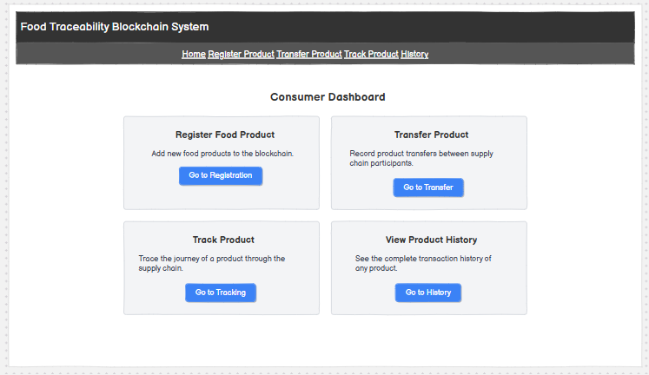2.Register Food Product 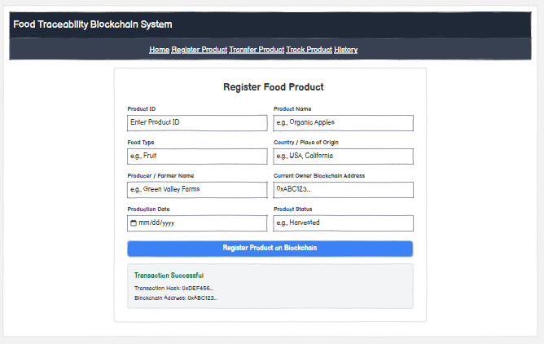3.Transfer & track the Product below : 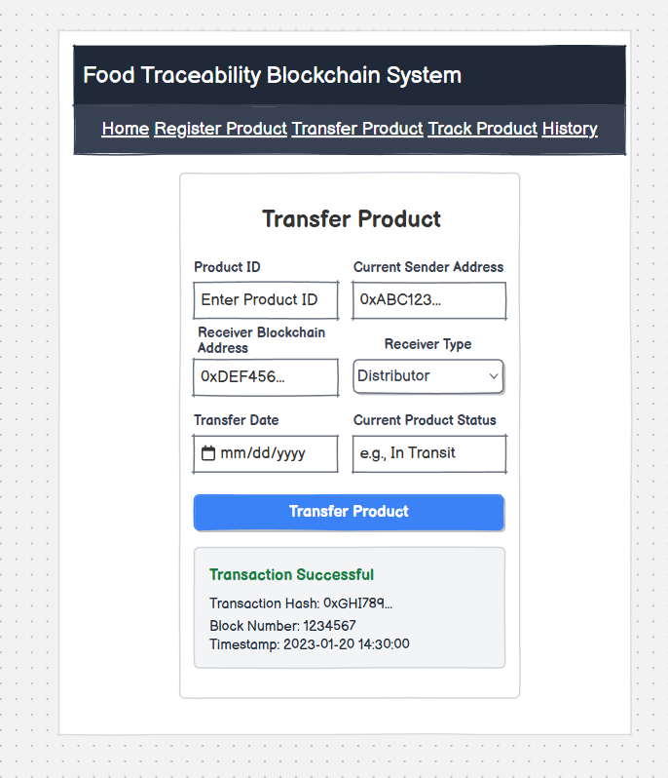4.ViewTransaction History: 